**DRM Roofing Glass and Aluminum and Iron Works Online Ordering System**

A System Analysis and Design Project

Presented to the

Faculty of the Department of

Computer Science

Immaculada Concepcion College

In partial fulfillment of the requirements for the Degree

Bachelor of Science in Computer Science

Presented by:

Team leader: Apostol, Neo Jierou A.

Programmer: Brillio, Juluis

Back end: Garcia, Jonel M.

Front end: Garcia, Adriano M.

Back end: Certifico, Norman E.

Researcher: Nash, Gailfred D.

System design: Halili, Glenn

John Gabriel Sambajon

Instructor

September 2024

**CHAPTER 1**

**INTRODUCTION**

1. **Background of the study**

Technology has changed our lives in many ways, from how we communicate and work to how we shop and entertain ourselves. Computers are at the heart of this change, helping us stay connected through emails, social media, and video calls. They make work easier by handling data, managing projects, and allowing remote teamwork. Overall, computers are essential in making our lives better and more efficient. The impact of technology on our daily lives can be seen in how it has changed the way we live, work, and communicate (Hillary, 2021).

Computing plays a crucial role in modern society, enhancing efficiency, productivity, and accessibility in various fields such as business, healthcare, education, government, and entertainment. The advantages of the study for the customers are they can order via online convenience, transparent information, secure payment options and even order tracking manage well secure. It drives progress in medical diagnostics, online learning, climate prediction, and logistics management, while also supporting global collaboration and informed decision-making. The adaptability of computing technology continues to improve everyday life, making it crucial for ongoing progress and innovation. The company currently manages material procurement using a manual ordering system. Staff members are responsible for tracking inventory levels, placing orders, and communicating with suppliers. This process involves manual entry and record-keeping for each order, with minimal automation and no real-time data on stock levels. Inventory counts and ordering decisions are often based on routine checks or estimates, and supplier coordination is handled directly by employees without the aid of automated tracking or demand forecasting tools. Online ordering systems have transformed how businesses handle orders and interact with customers by making the process more efficient, reducing errors, and improving satisfaction. These systems feature user-friendly interfaces, real-time inventory management, and secure payment processing. They use advanced algorithms to recommend products, track inventory levels, and optimize delivery routes. Theories like the Technology Acceptance Model and Systems Theory help explain how these systems are adopted and work effectively.

The DRM Hardware is located in Quirino Highway Pangarap village. Caloocan city, Philippines. The company's owner is David Rustria Mota. The research shows that the company needs to come up with new ideas to keep or grow. The company is doing well in its field, but it has to deal with new rivals and changing customer tastes. The company wants to use new technologies like online ordering system. The company’s recent financial reports show that their revenue is growing steadily, but their profits are being squeezed because costs are going up and there’s more competition. To improve how they work and make their customers satisfied. The company is having problems with its supply chain, which is causing issues with stock levels and delivery times. People now want personalized, fast, and mobile-friendly ordering options. Right now, other businesses struggle with taking orders especially during busy times. Their current manual ordering causes delays and mistakes, which frustrates customers. As more people prefer online ordering, it’s important for the company to adopt a strong online system. This project will provide convenience order anytime anywhere, various payment options, a variety of options, well detailed descriptions and images helping the business succeed in a competitive market.

1. **Objectives of the study**

**General Objective**

The general objective of this study is to develop an online ordering system for DRM Roofing and glass and Aluminum iron works that will allow customers to effortlessly browse products, customize their selections, order products and transact payments. The developers want to ensure the client receive instant order confirmations and can track their deliveries. Reducing human error, and improving the general customer experience is the primary objectives. The goal of this system's implementation is to improve DRM Roofing's order management process.

**Specific Objectives**

1. The Online Ordering system aims to improve the purchasing time of customers from 20 minutes to 10 minutes.
2. The Online Ordering system aims to improve the overall customer experience satisfaction. By analyzing customer feedback and usage patterns, the study seeks to identify key areas for improvement and develop strategies to increase customer retention from 60% to 100%.
3. The DRM online ordering system aims to automate the ordering process by reducing the need for manual process, which in turn minimizes the chances of human error. This system allowing orders to be processed more quickly, secured and accurately to 100%.
4. DRM Online Ordering System also aims to improve service orders during store hours and off-store hours which will operate 24/7.

**REVIEW OF THE RELATED LITERATURE, STUDIES, and SYSTEMS**

1. **Review of Related Literature**

**Foreign Literature**

Base on the literature of Charlene L, et al (2020) entitled "Review of Online Food Delivery Platforms and their Impacts on Sustainability".. Economic growth and increasing broadband penetration are driving the global expansion of e-commerce. Consumers are increasingly using online services as their disposable income increases, electronic payments become more trustworthy, and the range of suppliers and the size of their delivery networks expand.

Ali Abdallah Alalwan (2020). Mobile food ordering apps: An empirical study of the factors affecting customer e-satisfaction and continued intention to reuse. Mobile food ordering apps (MFOAs) have been widely considered in the restaurant sector as innovative channels to reach customers and provide them with high-quality services. However, there are important questions regarding the impact of implementing MFOAs on customer satisfaction and on customers’ intention to reuse such apps. Several studies have examined the outcomes of using MFOAs from the customer’s perspective.

Helge A.W, Vahid A., Jian S.D., John R. (2011). Category-based food ordering processes.  The food industry presents an important area to apply new technology and automation. Especially, food ordering processes, that describe the transition of products’ physical arrangement from disarray to a structural order, play a major role and will be considered in this paper. This kind of food processes will be extracted from other types of processes and clearly defined.

Yang J. F and Mohd Z. S (2024). Tang Huat Restaurant Online Food Ordering System.  Online Food ordering system is a web-based system that allows the consumer to order food from the Internet using a web browser. TANG HUAT RESTAURANT is a food-selling business that sells a variety of food using WhatsApp and Telegram. The problems faced by the owner are difficulty tracking back orders, the need to calculate the monthly sales manually and not having a proper online menu.

Atieleya B. M. Y. and Nurul H. A. R. (2024). Eco Grocer Online Ordering System with Data Retention Policy.  Eco Grocer is a grocer shop that sells daily necessities such as groceries. Currently, Eco Grocer only depends on customers that are shopping physically, and the business is not well-known in the area. By adopting the online ordering system, it helps to widen the market. Eco Grocer online ordering system is an ordering system developed to ease customers to buy necessities.

**Review of Related Literature**

**Local Literature**

Allysa Mae M. Castillo, Louie John L. Salonga, John Allen L. Sia, and Michael N. Young (2020). Improving Fast-Food Restaurants’ Method of Operation: Automated Drive-Through Ordering System. There is a need for a fast-food restaurant to pay attention to delays for a business to satisfy its customers as longer waiting time has a negative impact on customer service satisfaction (Dube-Rioux, Schmitt, & Leclerc, 1989).

Yang J. F and Mohd Z. S (2024). Tang Huat Restaurant Online Food Ordering System.  Online Food ordering system is a web-based system that allows the consumer to order food from the Internet using a web browser. TANG HUAT RESTAURANT is a food-selling business that sells a variety of food using WhatsApp and Telegram. The problems faced by the owner are difficulty tracking back orders, the need to calculate the monthly sales manually and not having a proper online menu.

Charnelle A. Grajo (2024). The Impact of Digital Shopping on Buying Decisions:  The Case of Online Shoppers in Juban, Sorsogon. Digital shopping became a popular option for purchasing goods and availing services when e-commerce was introduced and given a significant role in the retail industry. This technology-propelled phenomenon that creates an impact to the buying decisions of consumers. Probing the impact of digital shopping on the buying decisions of consumers residing in a rural area who tend to be the recent target of a fore cited phenomenon was the focus of this study.

Karla M. B., Ray A. A., Vince C. C., Gian C. G., Naisha R., Zirvin K V. & Josephine D. C. (2021)., Simflow: An Inventory, Sales, and Ordering System for a Local Foods Producer., Businesses in the Philippines, whether micro, small, or medium, are now forced to

Jenefer P. B.,Marie Chona M. B. ,Kristine C. M. Edward B. P. ,Bienvenido B. A. ,Victor S. B. , Mark R. C.  and Jenny Lyn O. C. (2020). Dynamic Online Ordering and Data-Driven Inventory Management System with SMS for Security. Modern technology has made the requirement for information flow to be quick and effective.

**b. Review of Related Studies**

**Foreign Literature**

Keaton Y. (2024), Implementing Customizable Online Food Ordering System Using Web Based Application, The importance of a portfolio website cannot be ignored, especially for micro, small, and medium enterprises (MSMEs) who want to increase their business visibility and credibility. Therefore, this website development project is expected to provide MSMEs like CV Putra Pahala Tua an effective tool to compete in an increasingly digitized market. The entire portfolio website and its complementary systems (online ordering system and admin panel) development process uses the Scrum framework guided by Agile principles.The features developed included: home page, news page, catalog page, login page, as well as an online ordering system for customers to make order requests and an admin panel for company employees to manage front-page content and order requests from customers.

K Madhusudan R, T Sai K,. (2024),. Network For Ordering Food Online, The use of advanced computer software and hardware, the Online Food Ordering approach seeks to automate the current manual approach in order to suit user needs and save critical data and information for extended periods of time that can be easily manipulated and accessed. The required hardware and software are easily accessible and user-friendly. Keeping track of data, including shopping cart, item category, food products, delivery address, and order, is the main objective of the online meal ordering system.

**Local Literature**

Catubag, Joaquin L, C., Fabian Jr., Joseph DG., Garcia, E, J, Avila, Rozel B., Cabance, P, J, D.v (2024), Angels and Lemons’ E-Ordering: Development of a Web-Based Ordering System forAngels and Lemons, This research presents the development of "Angels and Lemons’ E-Ordering," a web-based ordering system designed for Angels and Lemons, a lemonade-selling business. The system aims to streamline the ordering process, reduce errors in order-taking, and enhance customer experience. Key features include a carting mechanism For orders, mock-ups of payment gateways (specifically G-Cash and Pay Maya) to mitigate the risk of bogus buyers, and a customer staff admin manager interface for efficient order fulfillment. Customers can place their orders on the web site or upfront. In the web site, they may only place pick-up orders by which they can choose their preferred pick-up times for their orders.

Clark James S., Rogena C., Adrian M., King Jehu II R., Paul Jr. Bokingkito, Lemuel Clark V. (2024) Siargao Fresh Picks: Optimizing Sustainable Food Product Orders and Delivery System., The increasing use of food delivery services, driven by apps and websites, has significantly changed how food is ordered And delivered in highly urbanized cities across various countries. These services make it easy to obtain food from a variety of sources Such as restaurants, fast-food chains, local cafes, and grocery stores. However, they also face issues such as late deliveries, poor food Quality, and problems with payment and delivery staff. This study aims to review existing research on food delivery apps and websites To identify new areas for future research that could address these issues.

1. Review of Related Systems/Projects

Inspired by similar systems such as Ace Hardware and Home Depot in the Philippines, the proposed online ordering system for DRM Roofing Glass and Aluminum Iron Works incorporates features like improved supplier-client coordination, varied product management, and user-friendly interfaces. However, in contrast to these general retail platforms, our system is specifically designed for the construction industry, providing customized solutions for roofing, aluminum, and iron works, bulk-order capabilities, and specialized customer support for suppliers and contractors.

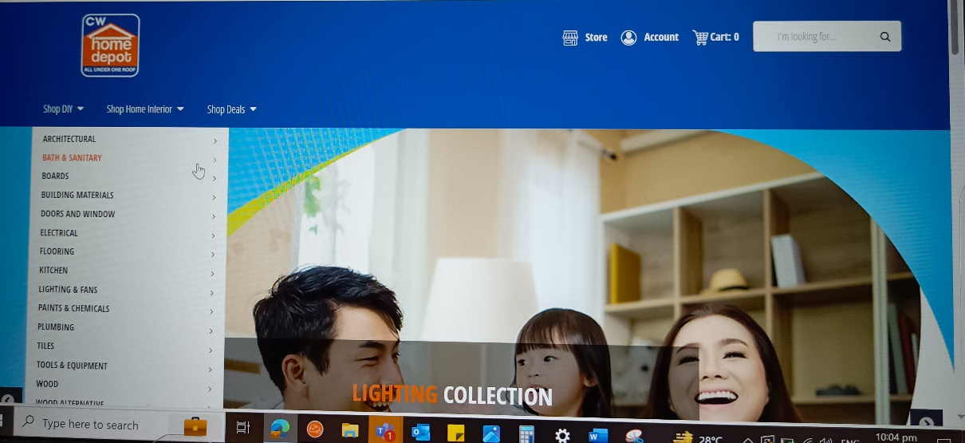

*Fig No : Description*

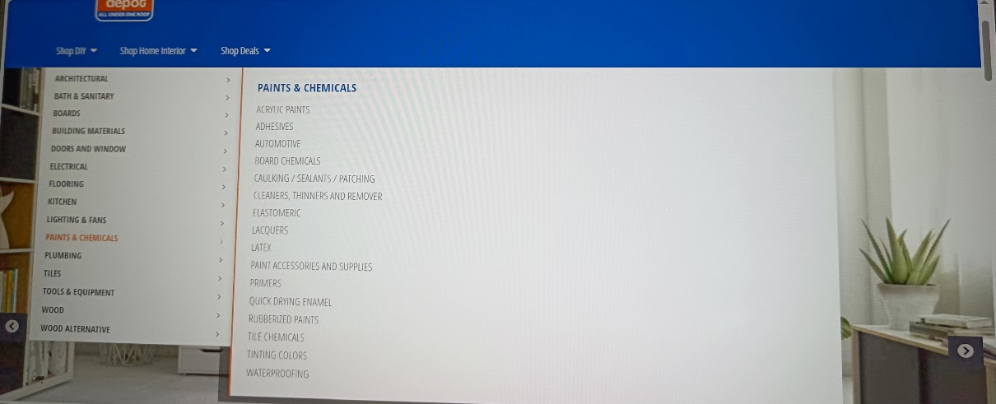

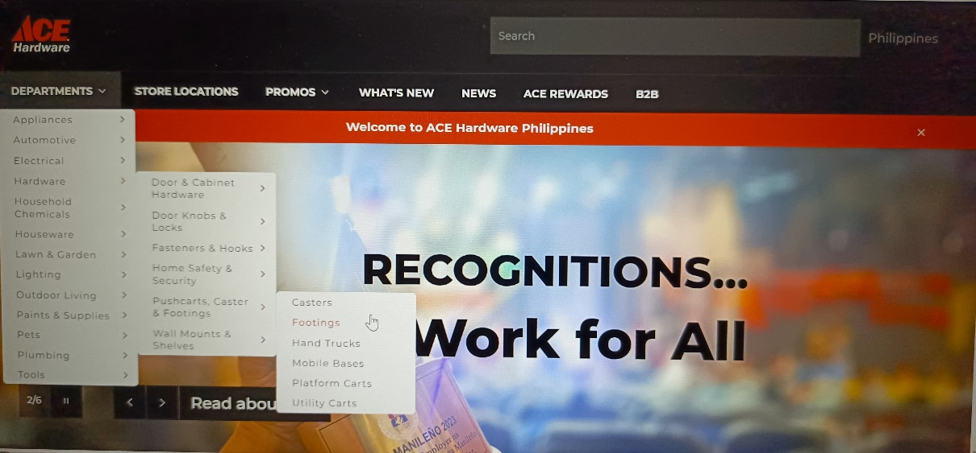

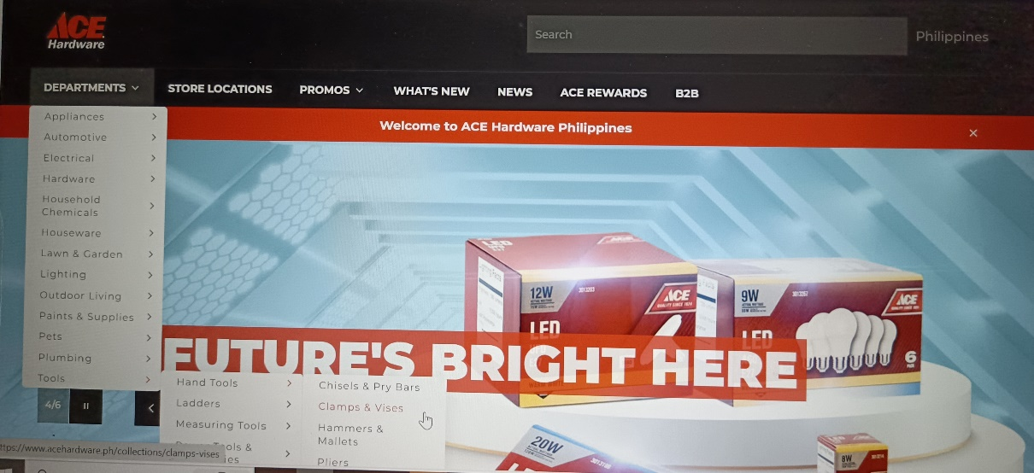

**9-**

**IV. Conceptual Framework**

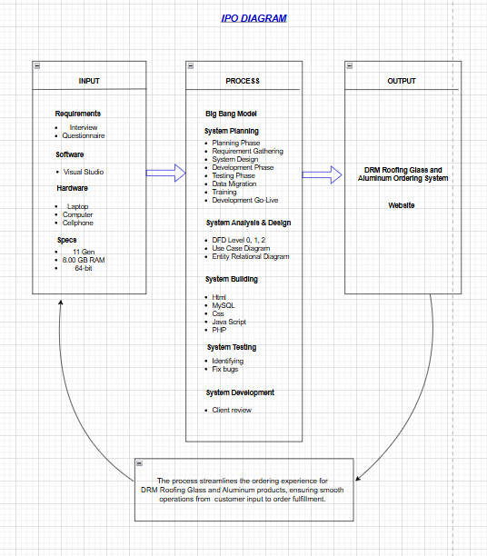

The **Input** phase begins with gathering essential knowledge through interviews and questionnaires, alongside specifying software requirements (like Visual Studio) and hardware specifications (laptops, computers, cellphones). The **Process** involves several key stages: utilizing the Big Bang Model for project planning, system analysis and design (through Data Flow Diagrams, Use Case diagrams, and Entity Relationship Diagrams), system building (using technologies like HTML, SQL, CSS, JavaScript, and PHP), and testing for bug fixes. Once the system is thoroughly tested, it moves to deployment and client review. The final **Output** is a fully functional web application, serving as the ordering system for DRM Roofing, Aluminum, and Glass, streamlining the ordering process for users from customer input to final fulfillment.

**Statement of the problem**

The DRM Roofing Glass and Aluminum Online Ordering System attempts to solve important problems in the construction industry, including the inefficiencies and difficulties related to conventional material ordering procedures. Many contractors and builders still use old-fashioned, time-consuming procedures that result in miscommunication, inefficient inventory management, and delays.

significantly raising project costs and deadlines. Furthermore, the sector is in dire need of digital solutions that improve operational effectiveness and accelerate procedures. Businesses run the danger of losing their competitive advantage in a market that is changing quickly without a strong online ordering system, therefore it's critical to identify solutions that address these common problems.

**General Problem**

The DRM roofing Glass and Aluminum Iron Works has been working to improve its overall services to customers. It has been a challenge to the company on how to deal with the demands of the customers in terms of purchasing the products from ordering up to delivery.

**Specific Problem**

1. DRM Roofing Glass and Aluminum Iron Works has been receiving negative feedback regarding Customer Convenience and Satisfaction resulting in a decrease in customers' return.
2. DRM Roofing, Glass, and Aluminum is facing Slow Order Processing Times, which is causing delays in services and making customers unsatisfied. This is leading to a decrease in the company's earnings.
3. The DRM roofing Glass and Aluminum Iron works only offers services during a limited time each day, which limits customer access and convenience. this restriction can lead to lost sales and customer dissatisfaction, as it does not meet the expectations of 24/7 availability commonly associated with online ordering systems.

**Definition Of Terms**

**Delivery Tracking.** A feature that enable to monitor the status and location of their orders in real time.

**Efficient.** The ability to maximize productivity and minimize waste, often measured in terms of time and resource us.

**Order Customization.** The ability for customers to modify their orders based on specific preferences or requirements.

**Product Catalogs**. A comprehensive listing of items available for purchase, often with descriptions, prices, and images.

**Shopping Cart**. A feature that allows customers to select and store items they wish to purchase before finalizing their order.

**Scope and Limitation of the Study**

**Scope**

The scope of this study is to create an online ordering system that addresses the specific needs of DRM Roofing Glass and Aluminum works The system will be designed to streamline ordering processes and enhance efficiency.

**Customers/Buyers Features:**

**Sign Up and Profile.** The system allows users to create personal accounts, which enhances their shopping experience. When users sign up, they can provide their personal information, such as name, address, and contact details. This information is securely stored and can be updated at any time. ensuring that the user's profile is always current.

**Menu Updates.** The system allows buyers to easily update the menu with new items, prices, and details. This feature ensures that the product catalog is always current and reflects the latest offerings. Buyers can add new products to the menu, update existing product descriptions, and adjust prices as needed.The buyers of DRM roofing glass and aluminum iron works are easily change the menu with new items, prices, and details.

* **Place Orders:** The system allows customers to place orders with ease. Customers can browse through the product catalog, select the items they need, and add them to their shopping cart. Once they have chosen their products, they can proceed to customize their orders based on specific preferences or requirements.
* **Payments:** The system securely handles payments through G cash This feature ensures that customers have convenient to complete their transactions. The system uses security protocols to protect sensitive payment information.
* **Track Orders:** The system includes a feature that allows customers to monitor the status and location of their orders in real-time. From the moment an order is placed, customers can follow its journey through various stages, such as processing, dispatch, and delivery.

**Staff Features:**

* **Manage Stock:** When an item is sold, the system automatically updates the inventory count, reflecting the new stock level. If the stock level of a particular item falls below a predefined threshold, the system can trigger a restock alert, notifying the staff to reorder the item. This proactive approach helps maintain optimal inventory levels, ensuring the items are always in stock and available for customers.
* **Receiving Orders**: When a customer places an order through the system, the system immediately sends a notification to the staff. This notification can be in the form of an email or an alert within the system's dashboard. The instant notification ensures that no order is overlooked, allowing the staff to promptly acknowledge and begin processing the order.
* **Managing User Accounts**: Once an account is created, employees can update customer information as needed. This might include changes to contact details, addresses, or preferences. Keeping this information up-to-date ensures that all communications and deliveries are accurate and efficient.
* **Payment Processing**: The system securely handles payments, allowing staff to process transactions quickly and accurately. This includes managing various payment methods such as credit cards and digital wallets.

**Admin Feature:**

* **Dashboard**: Admins have access to detailed customer profiles, including contact information, order history, and preferences. This allows for personalized customer interactions and better service. Admins can update customer information, resolve issues, and provide tailored support based on individual customer needs.
* **Inventory Management**: The interface provides real-time visibility into inventory levels, allowing admins to monitor stock availability and manage restocking efficiently. Admins can update inventory counts, set reorder points, and receive alerts when stock levels are low. This helps prevent stockouts and overstock situations, ensuring that products are always available for customers.
* **Security and Access Control**: Manage user permissions and access levels to ensure that sensitive information is protected and only accessible to authorized personnel.
* **Settings and Configuration**: Customize system settings, including language preferences, currency, tax rates, and shipping options, to suit the business's needs.

**Delimitations of the Study**

* Operation time of ordering for customers will cover 24/7.

**Limitation of the Study**

The study will be delimited to focus on the specific requirements of DRM Roofing Glass and aluminum works It will not address broader issues related to Online Ordering in general or explore other types of Online ordering systems.

**Customers/Buyers:**

* **Limited Personalization:** If a customer wants to select a specific size, color, or add special instructions to their order but the system does not allow for these modifications,
* **Delivery Time**: Depending on the shipping method and location, delivery times can vary. Customers may experience delays, especially during peak seasons.
* **Limited Payment Options**: The system may not support all payment methods. like credit card, debit cards, digital wallets, or bank transfers.

**Admins:**

* **Technical Challenges:** Admins may face technical issues such as system downtime, software bugs, or integration problems with other systems.
* **User Training and Support:**  Admins are often responsible for training staff and providing ongoing support. This includes helping users navigate the system, troubleshooting issues, and ensuring that all team members are proficient in using the system.

**Significance of the study**

**A. Contribution to knowledge**

The innovation of this project Online ordering system is specifically tailored for DRM roofing glass & aluminum Iron works provides a comprehensive catalog that includes detailed descriptions, high-quality images, and specifications for each product. This feature is designed to help customers make well-informed purchasing decisions. The detailed descriptions offer in-depth information about the products, such as their features, benefits, and usage instructions. High-quality images give customers a clear visual representation of the products, allowing them to see exactly what they are buying. Additionally, the specifications section provides technical details and measurements, ensuring that customers have all the necessary information to choose the right product for their needs. This thorough and transparent approach enhances the shopping experience by reducing uncertainty and increasing customer confidence in their purchases. Customers can also leave feedback and reviews on products and their overall shopping experience. This feedback is invaluable for the company as it helps identify areas for improvement and ensures that the products and services meet customer expectations. By actively encouraging and utilizing customer feedback, the company can continuously enhance its offerings and maintain high levels of customer satisfaction. The DRM online ordering system provides instant order confirmations via email. This feature ensures that customers are immediately informed that their orders have been successfully placed.

**B. Beneficiaries of the study**

**A. DRM Roofing Glass and aluminum works Business**. this system opens the door to a larger customer base, helping them streamline operations and boost sales through improved inventory management and quicker order processing.

**B. DRM Roofing Glass and aluminum works Customers:** enjoy the convenience of an online ordering system, which saves them time and gives them access to a wider selection of products. They appreciate the ability to customize their orders and easily track deliveries, making their shopping experience more enjoyable.

**C. DRM Roofing Glass and aluminum works Employees:** benefit too, as automated processes lighten their workloads, allowing them to work more efficiently and focus on higher-value tasks instead of manual order handling.

**D.** **Future Software Developers:** The project serves as a valuable model for designing similar Online Ordering systems.

**CHAPTER 2**

**METHODOLOGY**

1. **System Analysis**

The problem focuses on the incompetence that DRM Roofing Glass and Aluminum and iron works encountered throughout their old-fashioned manual ordering process. Long waiting times, queues to buy items, smokey places, So much noise. These competences include things like miscommunications, delayed order fulfillment, and poor inventory management. According to our team's investigation, these operational flaws have a negative impact on both customer satisfaction and the competitiveness of the company. A feasibility analysis conducted as part of the first assessment determined the necessity of a digital system that enhances service delivery and acceleration ordering methods. Our team performed surveys, observations, and interviews with important stakeholders like suppliers, customers, and contractors to obtain accurate information. Additionally, online research and testing were used to learn existing market requirements and how the suggested solution may suit these objectives. fifty respondents from the company's internal team and customer base had been chosen for the sampling, which clarified the need for a capable trustworthy online ordering system. Almost all participants in the data collection laid out strong support for the online development with the necessity of features like safe payments, real-time tracking, and a simple user interface. The design and structure of the proposed system were informed by those results, providing that it would fulfill the needs provided and be straightforward for deployment.

**a. Current System Utilized**

In the present time, DRM Roofing Glass and Aluminum and iron works utilizes a manual ordering procedure that requires phone orders or in-person transaction walk ins, waiting for a long time to fulfill the payment. Although this system has been in use for a while, it has demonstrated serious failings. in terms of managing both operational effectiveness and rising consumer needs. Orders must be placed in person at the construction supply store or over the phone, which causes delays, lengthy wait periods, and interruptions in communication. Since inventory management is executed by hand, mistakes like inventory shortages and overstocking can happen. The business's dependence on traditional methods and causes of not having an automated system. This has made it more difficult for the businesses to grow operations and fast enough to satisfy consumer expectations. Furthermore, in today's extremely difficult industry, the company cannot provide services like different payment choices, real-time order tracking, or efficient client service without an online system. The company's operational capabilities will be improved and these gaps will be filled by the proposed online ordering system.

**III.THE NEW SYSTEM (SYSTEM DESIGN)**

Requirements Analysis

The purpose of the project is to solve the problems faced by DRM Roofing Glass and Aluminum and iron works. It is a long time for customers to wait for their purchased equipment for their use, a smoky place, and very noisy. These problems not only affect the productivity and morale of employees, but also their health and well-being.

Using our team's survey, observations, and interviews with suppliers, customers, and contractors to find out what the market needs are. We got fifty, (50). respondents from the company's internal team and our sampling base, all supported online development with secure payment. Not only will it make their buying process easier, but it will also give them a sense of security.

Real-time monitoring through this system will reduce their anxiety and they will have more knowledge about the details of their transactions. And simple user interface for the design and structure of the system, an easy-to-use interface will allow customers to easily navigate the platform, so their experience will be more fun and less boring.

**IPO DIAGRAM (CONCEPTUAL DESIGN)**

The start of the Input phase involves collecting necessary information through interviews and surveys, as well as defining software needs such as Visual Studio and hardware details laptops, desktops, smartphones. The process includes multiple important phases: applying the Big Bang Model for project planning, analyzing and designing the system via Data Flow Diagrams, Use Case diagrams, and Entity Relationship Diagrams, developing the system using tools such as HTML SQL, CSS, JavaScript, and PHP, and conducting tests for debugging. After extensive testing, the system progresses to deployment and review by the client. The end result is a complete web application that serves as the ordering system for DRM Roofing, Aluminum, and Glass, simplifying the p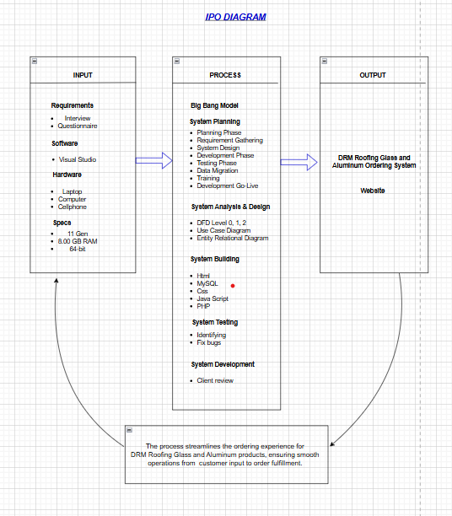rocess for users from input by customers to final completion.

**INFORMATION MODEL (CONCEPTUAL DESIGN)**

Our information model is divided into four categories: customer, owner, staff, and delivery man. The first is the customer, who buys a company's products for personal use. The staff is second, after the customer orders to pay after the customer pays the staff. The staff will handle the customer’s order who will call the delivery man. Third is the delivery man, who is responsible for delivering the order to the customer. The last is the owner, the owner will monitor the staff and delivery man if they are able to do their jobs in their respective positions in the company.

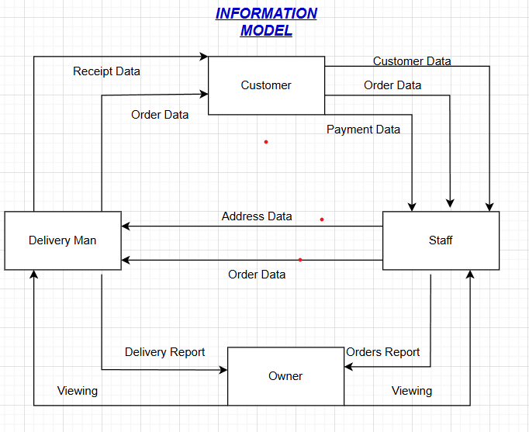

Admin

**FLOWCHART (PHYSICAL DESIGN)**

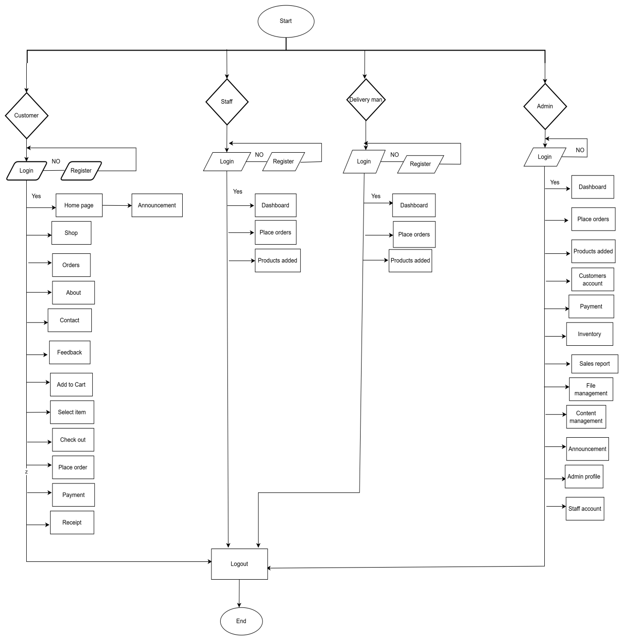

**CASE DIAGRAM (PHYSICAL DESIGN)**

Our case diagram is about two entities, first customer and Admin. His scope includes the customer, which is the ordering process, sold items, and inventory. In ordering, this contains the items that the customer will buy in the system, while in the sold item, these are the items that the customer has already purchased. Lastly is inventory, here the customer can choose trending items and what are the salable items in the company. Second is admin, he will monitor the database of item and inventory data what items are in the system and what are salable and unsalable items in the system.

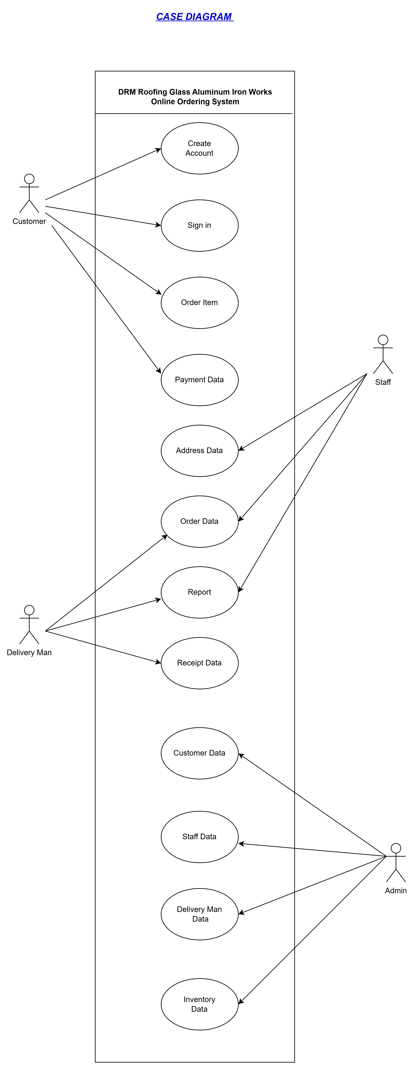

**CONTEXT DIAGRAM LEVEL 0 (PHYSICAL DESIGN)**

In our level 0, it contains the system that will be DRM Roofing Glass and Aluminum and iron works when an ordering system is created through web-page. As in our information model where DRM Roofing Glass and Aluminum and iron works do not yet have an ordering system, where they are here customers, staff, delivery man, and owner. At level 0, the company's process is shown when there is an ordering system. As in the information model, the customer buys items from the company, but when there is an ordering system through a webpage, the customer is required to register in the system.

Once the customer has created an account in the system, he can login to order items. The staff followed, just like the customer, the staff is required to register and login to the system, to take care of the customer's order in the system. Next is the delivery person such as the customer, and staff, it is necessary to register and login first to receive a call or message from the staff to deliver the customer's order to the system. next is the admin which is the owner of the company, like customers, staff, and delivery man, the admin needs to register and login in order to monitor what they do as customers, staff, and delivery man in his company.

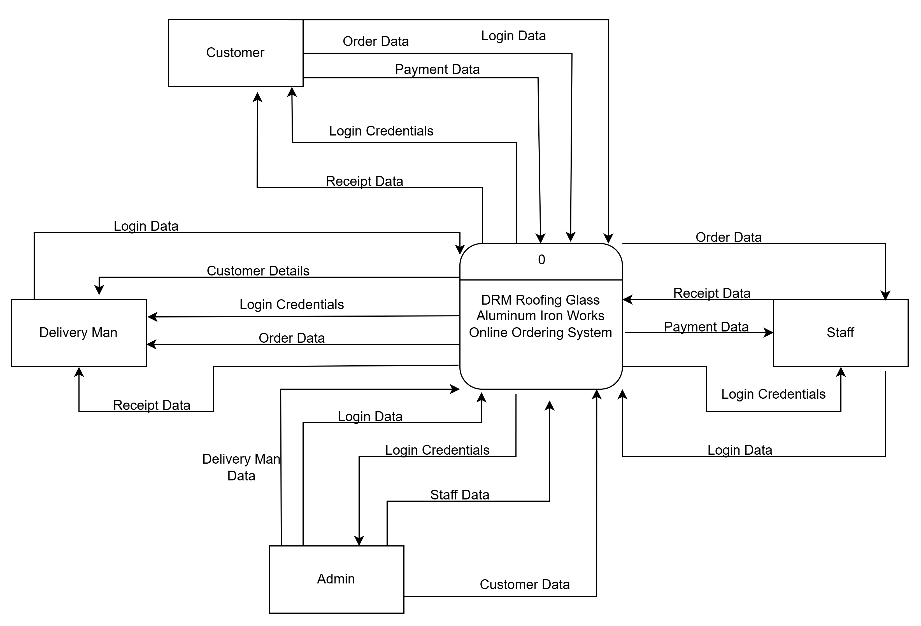

**LEVEL 1 Diagram (PHYSICAL DESIGN)**

In the level 1 diagram, this is where the information purchased by the customer enters the system from its registration and login. Those ordered by the customer will be processed by the staff. The staff will manage the customer's order. After being processed, the customer's order will go to the system's database where the system will report to the staff that the customer has an order. And staff will report to admin the databases that come from the customer's order in the system.

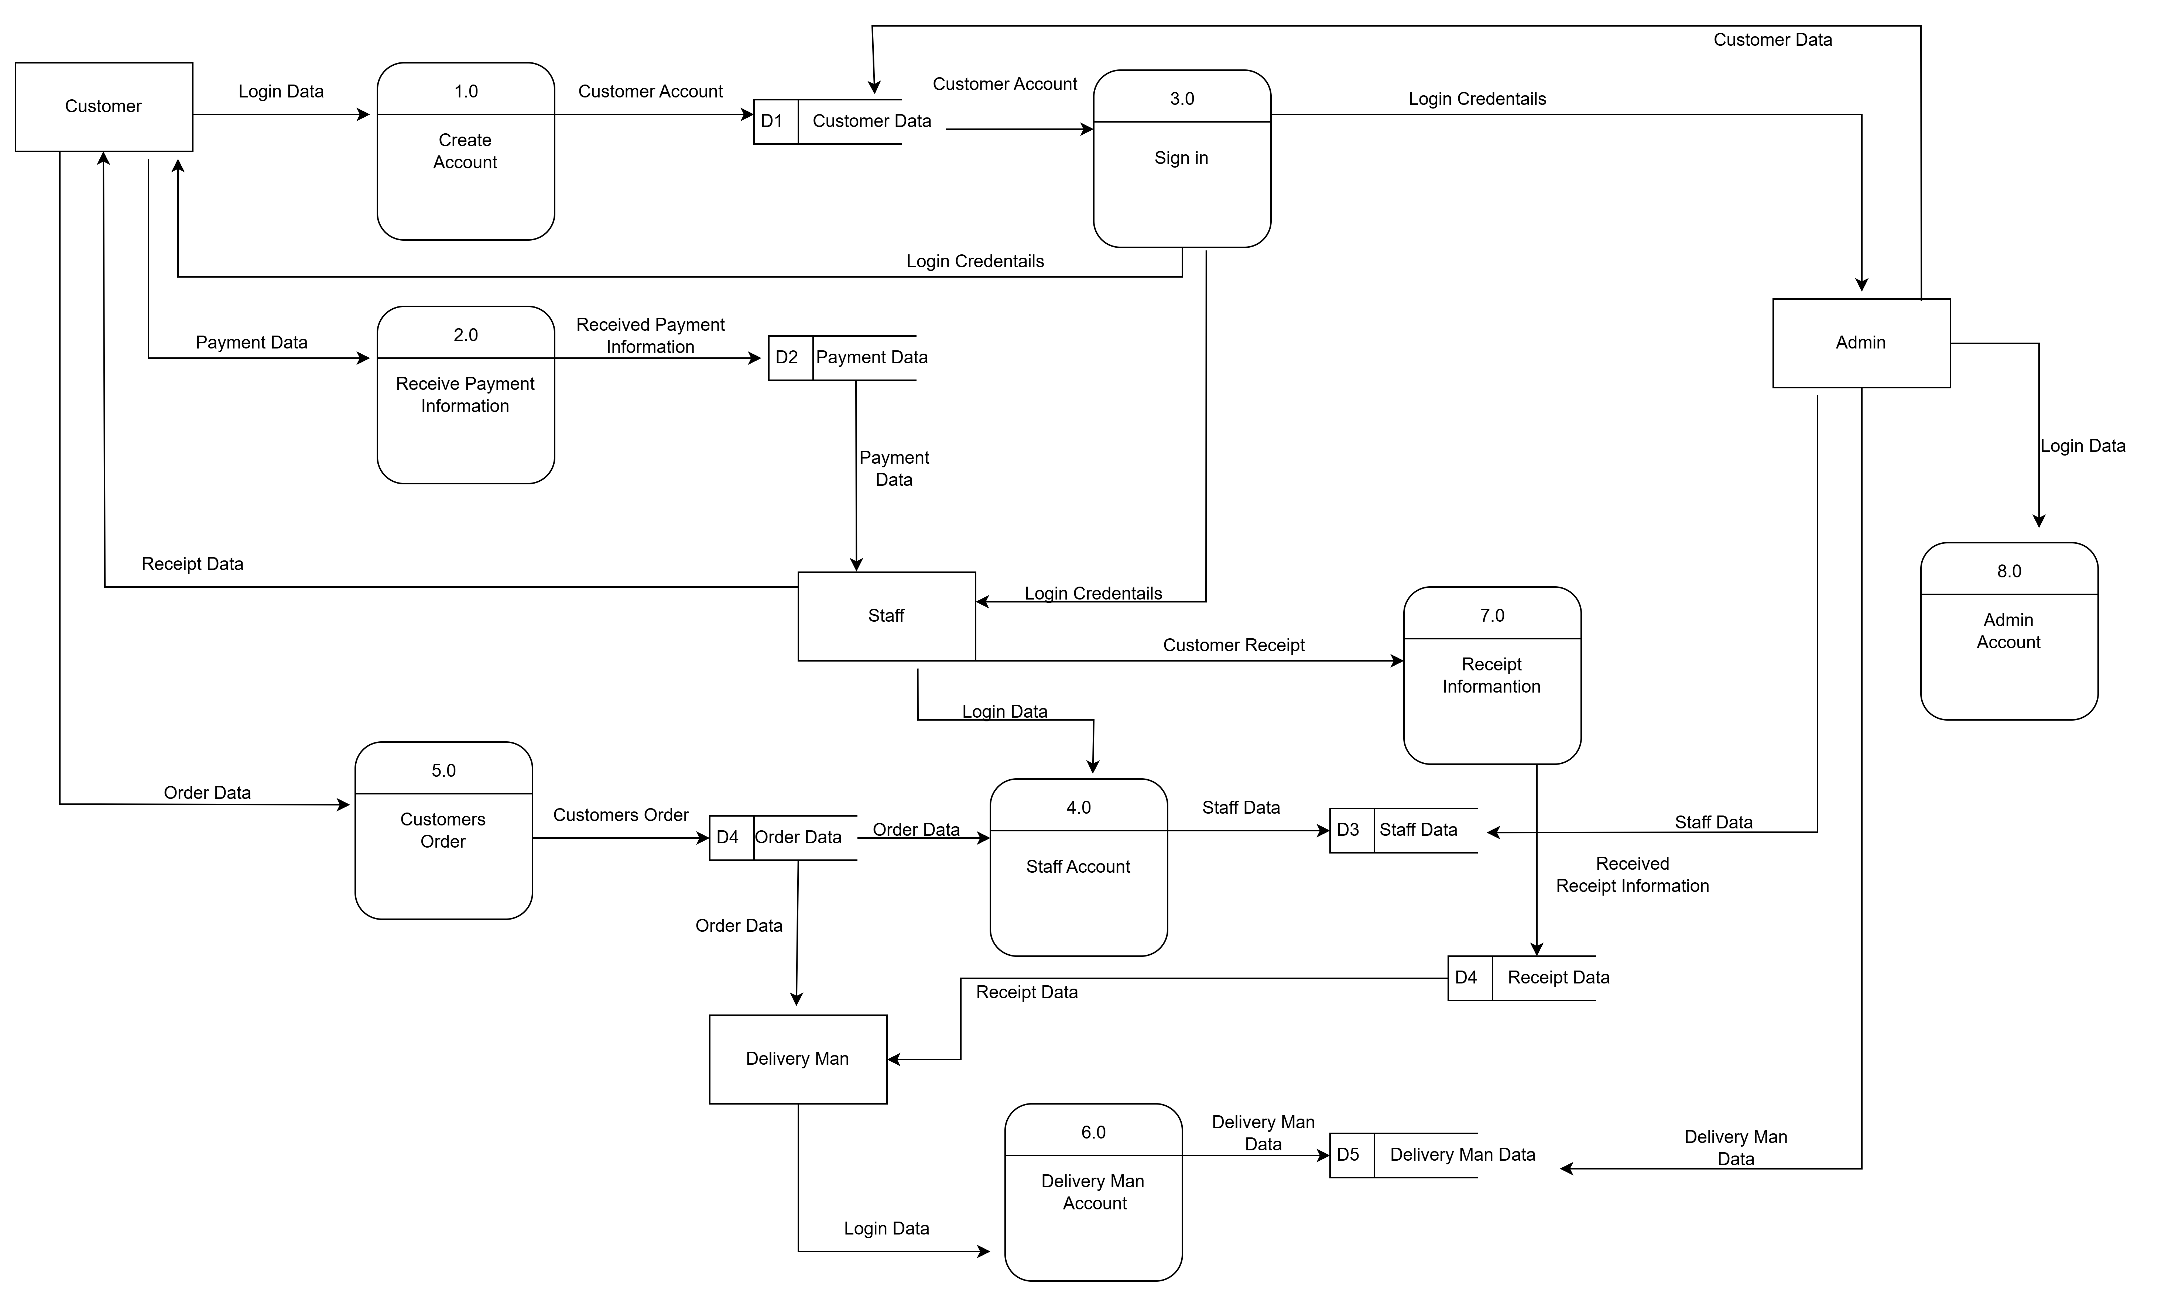

**Level 2 Diagram (PHYSICAL DESIGN)**

Our level 2 diagram is the process of from the item purchased by the customer from the system to payment processing where the customer will pay for the item ordered from the system. Just like in level 1, the customer orders items from the system, the staff will be able to manage his purchase and include its receipt. And from the staff, it will be sent to the delivery man where the delivery man is responsible for what the customer bought from the system.

Customer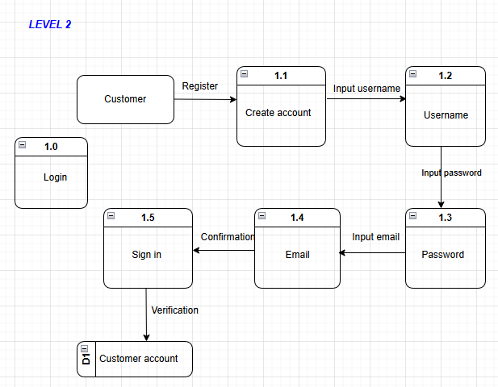

Staff

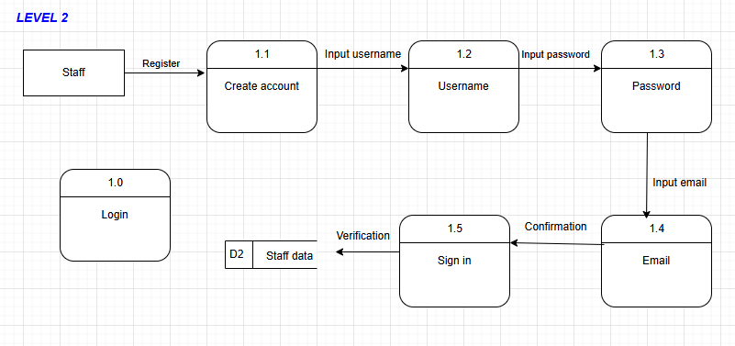

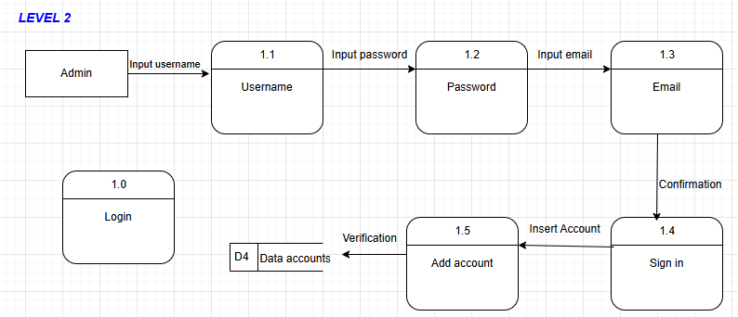Admin

**DATA MODELS (PHYSICAL DESIGN)**

This is where the customer's purchased information enters the system in the level 1 diagram, after registration and login. The staff will process the items ordered by the customer. The order will be handled by the staff. Once the customer's order is processed, it will be sent to the system's database, which will notify the staff of the customer's order. Staff will inform the administration about the databases that are related to the customer's order in the system. And for level 2 diagram illustrates the journey of an item purchased by the customer, starting from the system and ending at the payment processing stage where the customer settles the payment for the ordered item. Similarly to level 1, when the customer requests items through the system, the staff can handle the transaction and provide a receipt. Then, the staff will transfer it to the delivery person who is tasked with delivering the items purchased by the customer through the system.

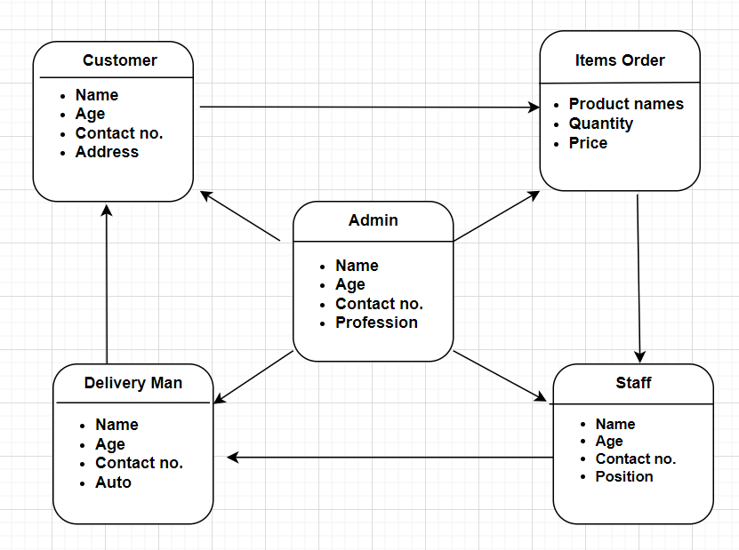

**ARCHITECTURE DESIGN**

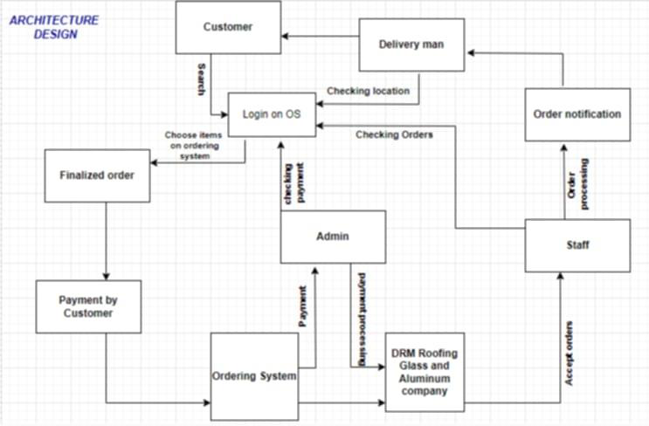

**DATABASE CONFIGURATION**   
 When accessing the customer's database, when the customer inputs information, such as name, address, age, contact no., etc. They will go to MySQL. MySQL is a relational database management system, where it i responsible for obtaining customer data as well as staff, delivery man, and admin.

**l. COMMUNICATION SYSTEM**

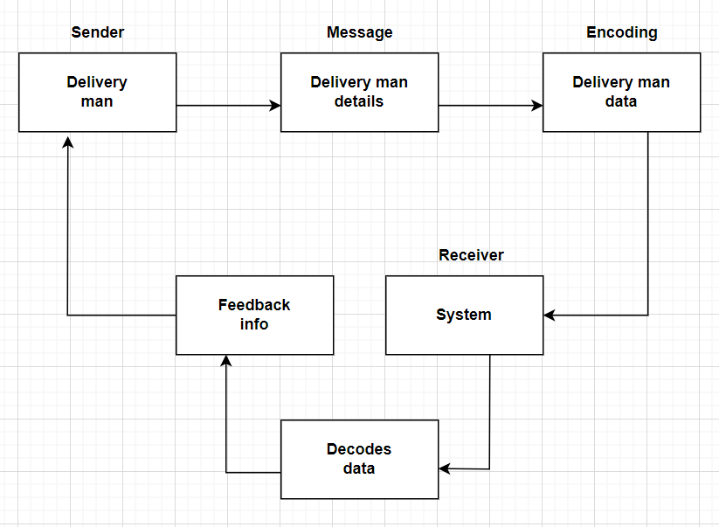This section includes the database programmer’s explanation on how database is being accessed while the system is being

**m. ALGORITHM DESIGN**

The Online Ordering System Algorithm commences with user authentication to ensure secure access, followed by functionalities that allow users to view or search for products. Once a product is selected, the algorithm facilitates the placement of an order, the processing of payment, and the issuance of an order confirmation along with an invoice. Additionally, users are provided with the option to view their order history, and the system concludes with a secure logout procedure. Throughout the entire process, the algorithm incorporates error handling mechanisms to ensure a seamless and secure user experience, minimizing disruptions and ensuring data integrity.

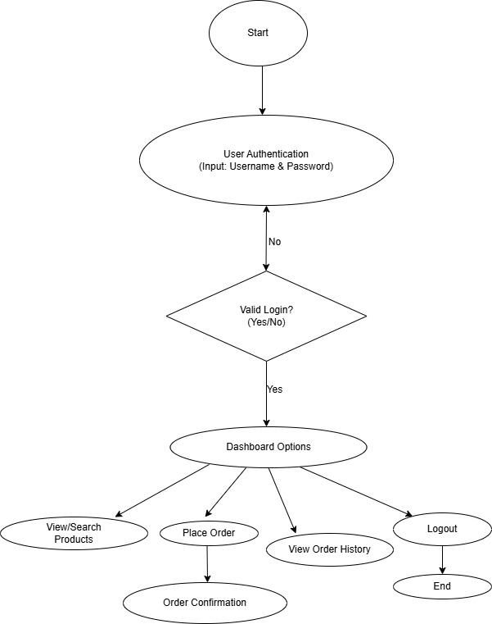

**CHAPTER 3**

**RESULTS**

1. **IMPLEMETATION PLAN**

* **Preparation** Before we launch the online ordering system, we need to make sure everything is in place.
  + - * Setting up the necessary hardware and software
      * Configuring the database and system settings
      * Conducting thorough testing and quality assurance Step
* **Deployment** Once we're ready, we'll deploy the system to the cloud infrastructure.
  + - * Hosting the system on a secure server
      * Installing necessary software and dependencies
      * Configuring system settings and database connections
* **Installation** To ensure a smooth roll out, we'll provide clear installation instructions for users.
  + - * Downloading and installing necessary software
      * Configuring system settings and importing data
* **Demonstration** We'll schedule a demonstration of the system for the target company. This will be conducted by Neo Apostol and the team on 11/10/24 at Quirino Highway 1596B pangarap Village. Caloocan city
* **Launch and Marketing** After the demonstration, we'll launch the system and promote it through
  + - * Social media campaigns
      * Email marketing
      * Trade show participation
* **Maintenance and Support** To ensure the system runs smoothly
  + - * Regular system updates and maintenance
      * Technical support for users
      * Continuous quality improvement

Overall, the deployment and delivery of the system should be a collaborative effort between the development team and DRM roofing glass and aluminum owner and staffs

1. **DEPLOYMENT PHASE REQUIREMENTS**
2. **Hardware Requirements**

* Computers/Laptops
* Cellphone

1. **Software Requirements**

The software requirements are the following:

* Visual Studio
* XAmpp
* My sql
* PHP

1. **Physical Facilities and Materials**

* Conference room
* Computer desktop or laptops
* White folder
* Ball pen
* Bond paper

1. **COMPANY FEEDBACK**

Overall the client was satisfied in our system, well design features and functionalities, need more clarifications about settings

Suggestions:

* Add tutorials or guides for new users.
* Enhance notifications and alerts for critical events.

**CHAPTER 4**

**DISCUSSION**

**I. OUTCOME OF THE IMPLEMENTATION**

This chapter presents the process involved in designing the system and device. It presents the different designs used. It also presents the testing and implementation plan for the system. The result and discussion of the development and testing are likewise presented in this chapter.

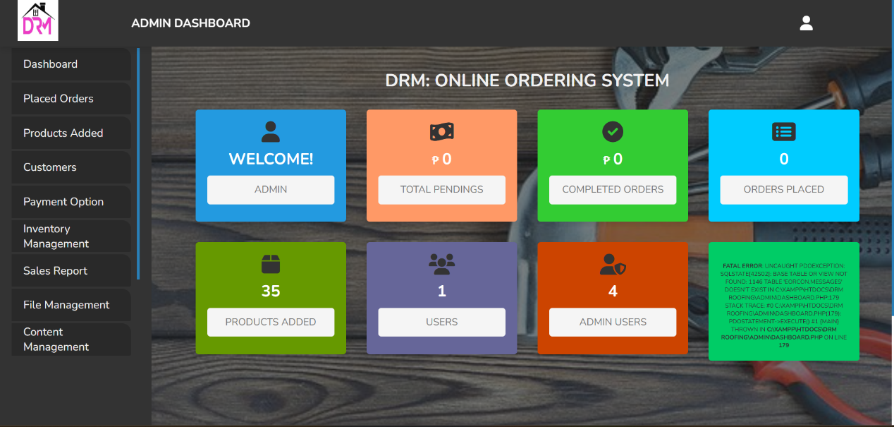

**Figure 1. Admin Dashboard**

`Figure 1, shows the Admin Dashboard. The system requires the admin and client to login using the registered username and password in order to access the system and to perform the desired task. The password field is encrypted to ensure the security of data.

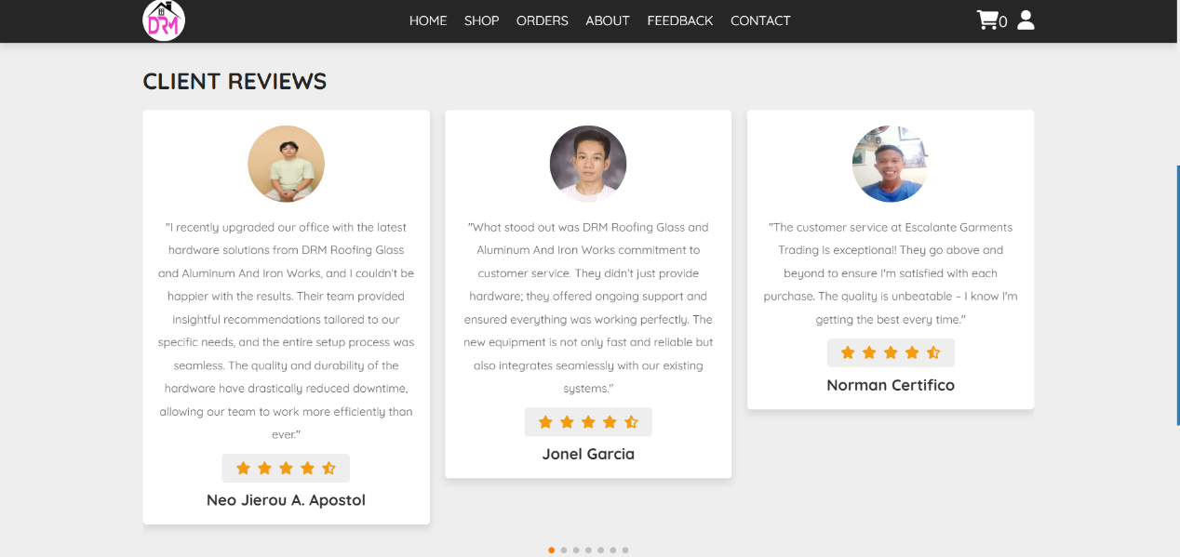

**Figure 2. Client’s Review**

In this part of the figure 2, users can view client reviews that highlight their experiences with the platform. Each review includes the client’s name, photo, and detailed feedback about the system’s features, such as ease of use, efficiency, and reliability. This section also displays a star rating for quick reference, helping potential users assess the overall satisfaction of previous clients.

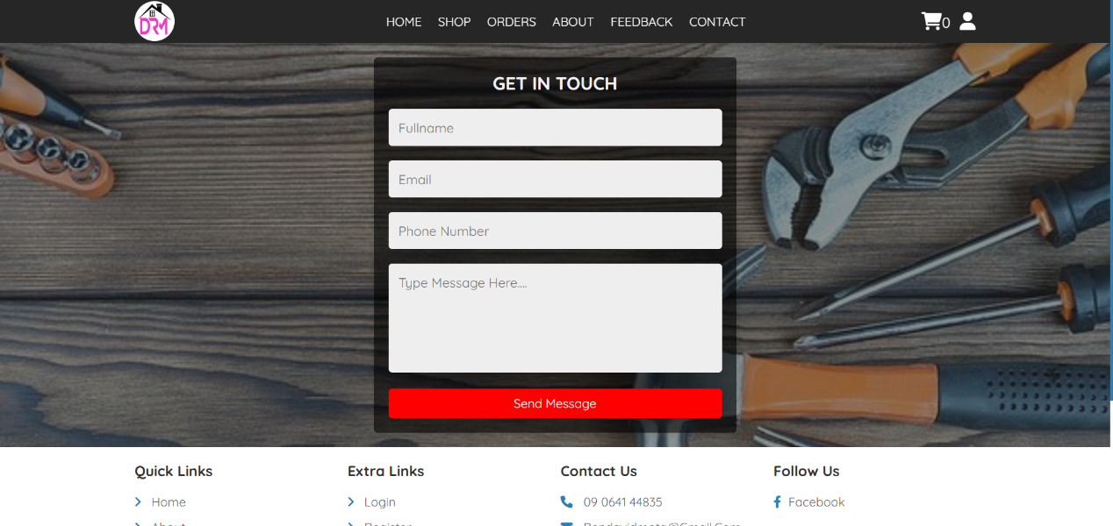

**Figure 3. Feedback**

In this part of the figure 3, labeled as the 'Feedback' section, users can fill out a form to send messages or provide comments regarding the system or their experience. The form includes fields for the user’s full name, email address, phone number, and a text box for their message. Once completed, users can submit their feedback by clicking the 'Send Message' button.

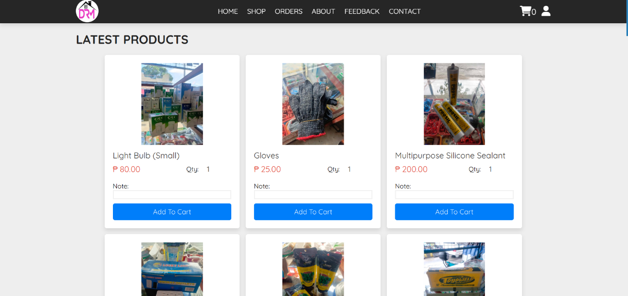

**Figure 4. Products**

In this part of the figure 4, labeled as the 'Products' section, users can view the latest products available for purchase. Each product is displayed with a clear image, its name, price, and available quantity. Below each product, there is an 'Add to Cart' button that allows users to include the item in their shopping cart for checkout. This section is designed to make browsing and selecting items straightforward and efficient, giving users a quick overview of the products offered by the system.

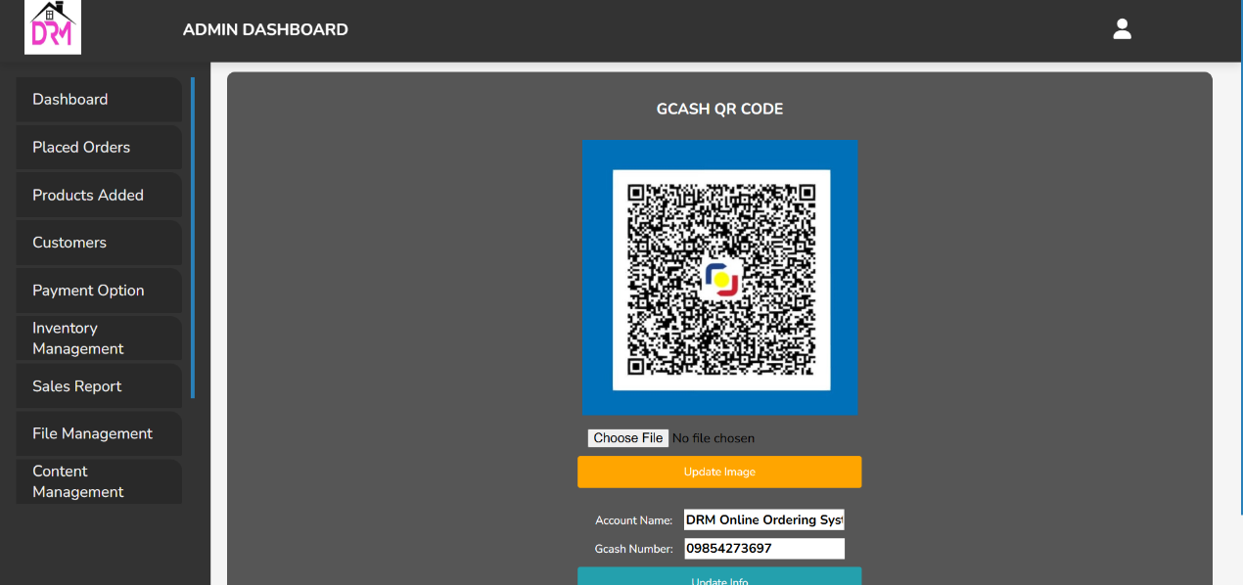

**Figure 5. Payment**

In the figure 5, users can choose between two payment options: 'GCash' and 'QR Code.' The 'GCash' option allows users to complete their payments securely through the GCash mobile wallet, while the 'QR Code' option enables users to scan a unique code using their mobile banking app for easy and quick transactions. Both options offer a seamless and convenient way for users to make payments directly from their devices."

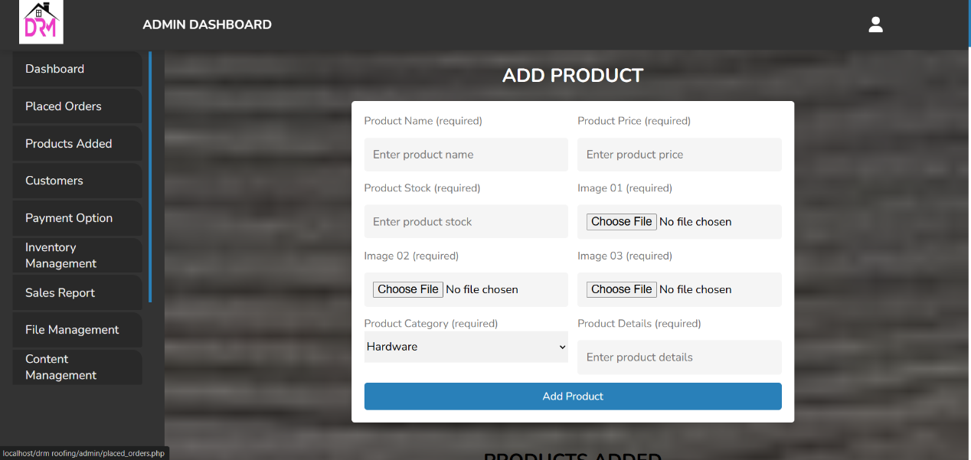

**Figure 6. Add Product**

In the figure 6, administrators or users with appropriate access can add new items to the system’s product catalog. This section typically includes fields for entering product details such as the product name, description, price, quantity, and an image upload option. Once all the necessary information is provided, users can submit the product to be added to the system's inventory, making it available for purchase. The 'Add Products' section is designed to streamline the process of managing the system's offerings, ensuring that new products are easily incorporated into the store."

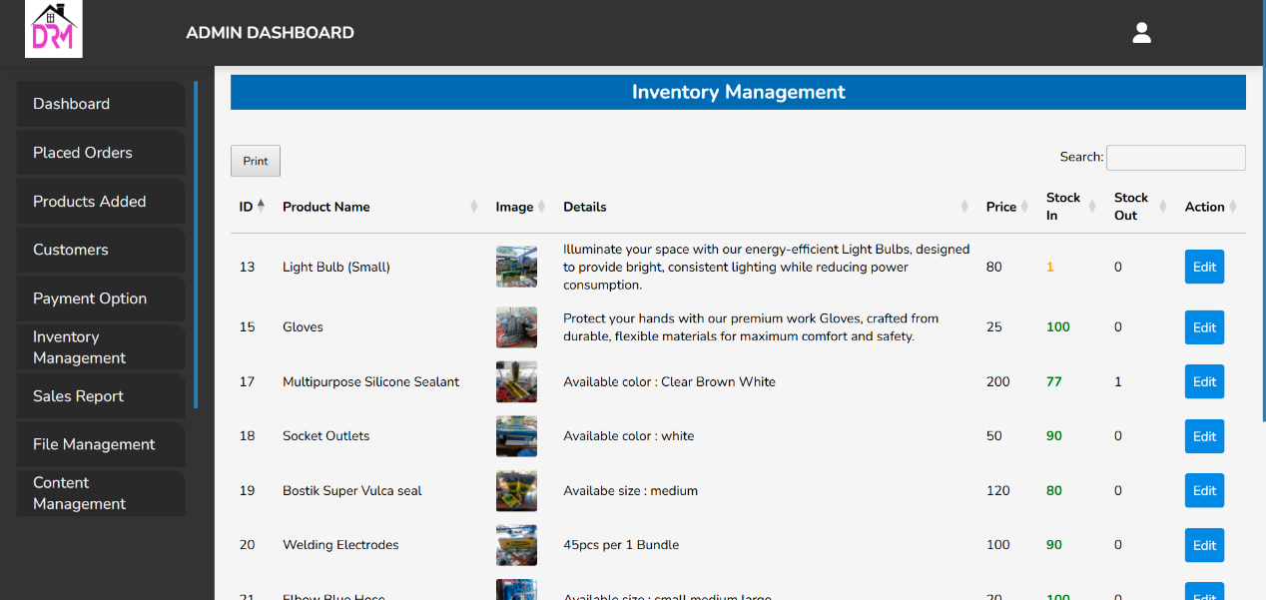

**Figure 7. Inventory Management**

In the figure 7, users can view and manage the details of products in stock. Each product is listed with its name, an image, detailed description, price, and current stock status. The section shows the number of items available ('In Stock') and the number of items that are out of stock ('Out of Stock'). Users can also take actions such as updating product details, adjusting inventory quantities, or marking items as out of stock. This section is designed to help administrators efficiently track and manage product availability, ensuring accurate and up-to-date inventory records."

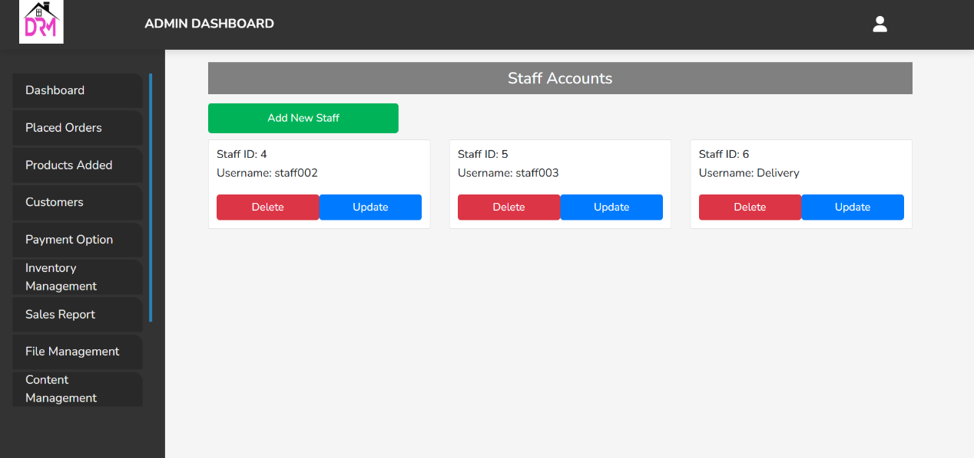

**Figure 8. Staff Accounts**

In the figure 8, each staff member is assigned a unique 'Staff ID,' such as 'Staff ID 5' and 'Staff ID 6.' Staff ID 6 is specifically designated for the delivery man, who is responsible for handling deliveries within the system. This section displays essential information such as the staff member’s name, role, contact details, and status. Administrators can manage these accounts by updating their information, assigning new roles, or deactivating accounts as necessary. The 'Staff Account' section helps ensure that each staff member, including delivery personnel, is properly tracked and managed within the system.

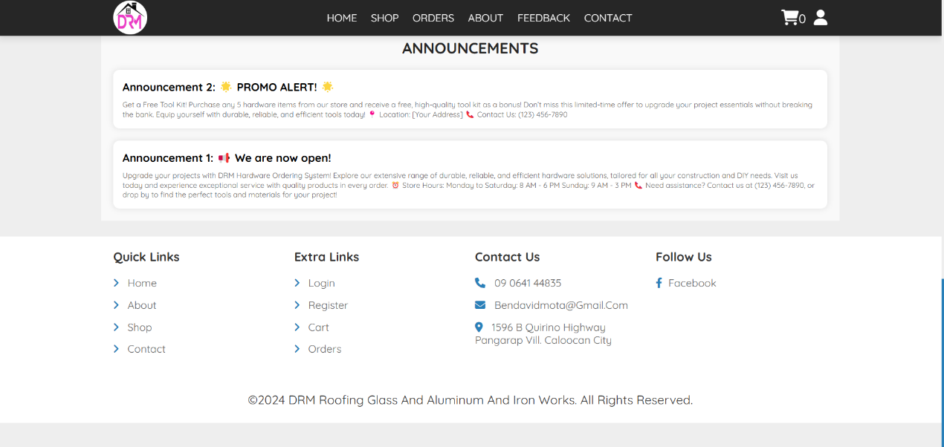

**Figure 9. Announcements**

In the figure 9, users can view important updates such as ongoing promotions, special offers, and announcements about whether the hardware materials store is open. This section serves as a quick way to keep customers informed about the latest news and deals. Additionally, it includes links to 'Quick Links,' 'Extra Links,' 'Contact Us,' and 'Follow Us,' making it easy for users to navigate to other sections of the website. The 'Announcements' section helps ensure that users stay up to date with current promotions and store availability, while also providing convenient access to key site pages.

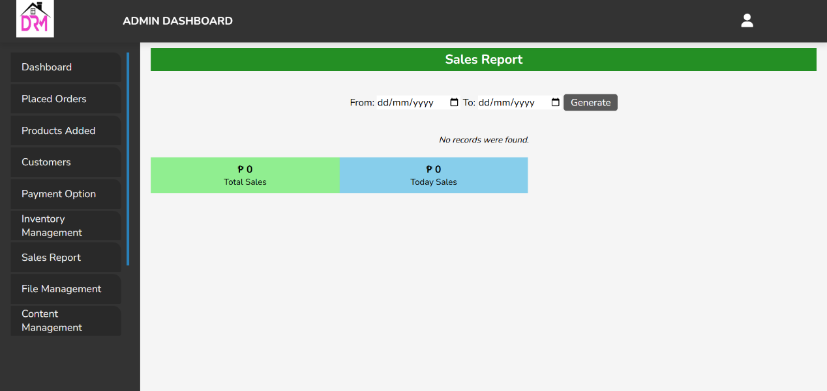

**Figure 10. Sales Report**

In the figure 10, users can access detailed records of the system's sales activities. This section typically displays a summary of transactions, including the total sales amount, individual product sales, and the number of items sold over a specific period. It may also provide filters to customize the report by date range, product categories, or sales status. The interface is designed to offer an intuitive view of sales performance, helping administrators track revenue, identify trends, and make informed decisions based on real-time data.

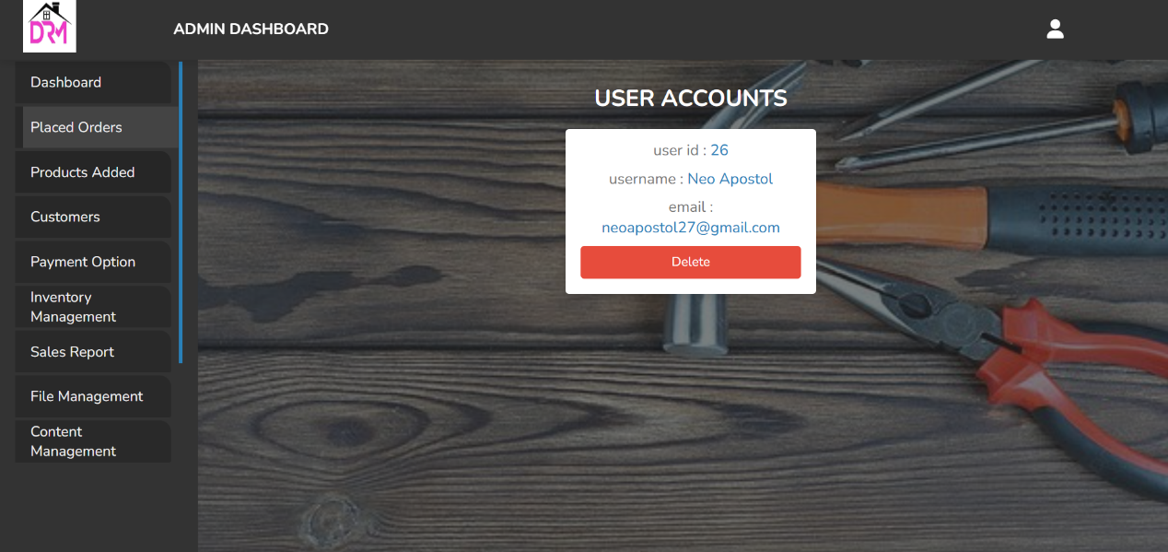

**Figure 11. User Accounts**

In the figure 11, administrators can manage the profiles of all registered users within the system. This section displays each user's account details, including their name, email address, account status, and any associated roles or permissions. Administrators can use this interface to view user activity, update account information, or deactivate accounts when necessary. The 'User Accounts' section is designed to provide an organized overview of user information, ensuring smooth management and maintenance of user profiles within the system.

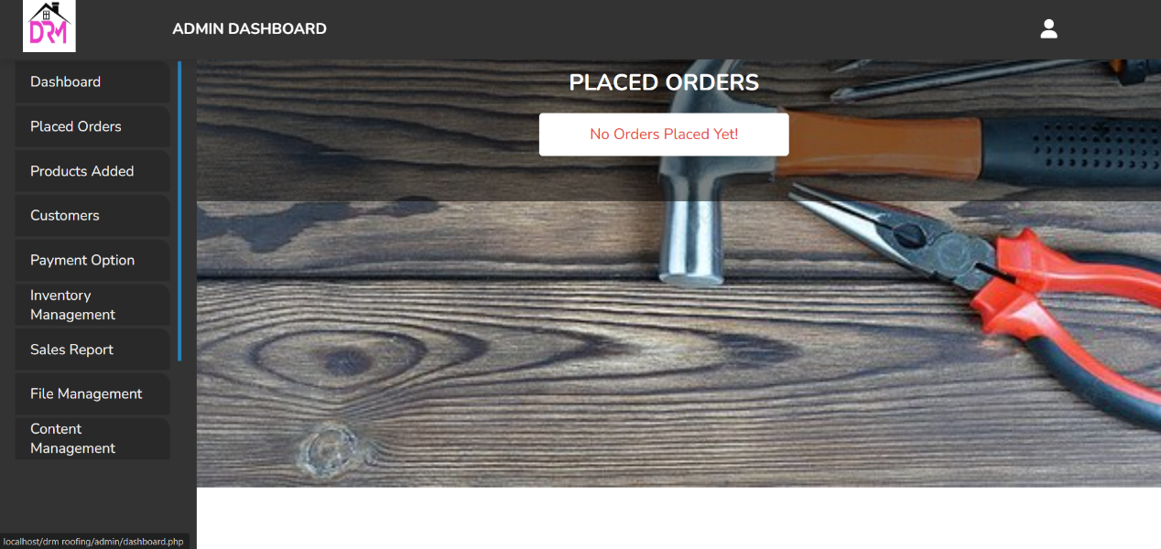

**Figure 12. Place Orders**

In the figure 12, users can view all orders that have been successfully placed through the system. This section includes key details for each order, such as the order number, customer name, product(s) ordered, order status, total amount, and date of purchase. Users can filter or sort orders by criteria like order date or status to quickly access the information they need. This section is designed to provide an organized and accessible overview of all current and past orders, helping administrators track and manage order fulfillment efficiently.

**II. IMPLEMENTATION RESULTS**

Present the outcome of the evaluation sheet and the summary of its

results based on the outcome of the testing phase. Discuss the strength and

weaknesses of the project according to each category of the SOFTWARE

**PRODUCT QUALITY:**

ISO 25010:2014 STANDARDS

A. Functional Suitability

B. Performance Efficiency

C. Compatibility

D. Interaction Compatibility

E. Reliability

F. Security

G. Maintainability

H. Flexibility

I. Safety

NON-ISO STANDARDS

A. USER INTERFACE

B. USER EXPERIENCE

1. **CONCLUSION**

Discuss the overall evaluation of your project in full detail according to

evaluation checklist (paragraph 1, 2, etc).

Discuss the outcome of the testing (did the company owner accepted or

rejected the project). Discuss if there are requested improvements in the future or

suggested features to be added on the system (last paragraph).